1. Creating Master Data of Customer Name, so operator just need to choose the data, not manually input to fill the form
2. Creating Master Data of Product Name, so operator just need to choose the data, not manually input to fill the form
3. Outbound Operation filling the Form

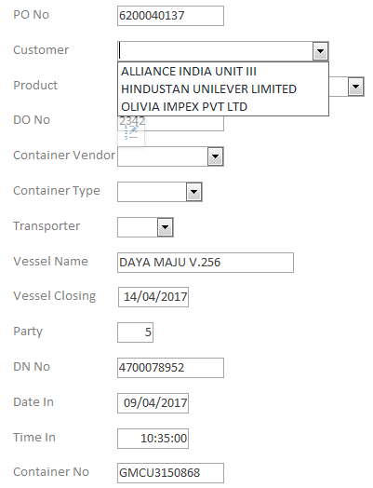

From Customer Name Master Data

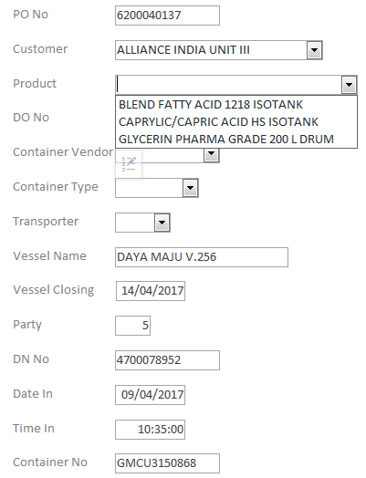

From Product Name Master Data

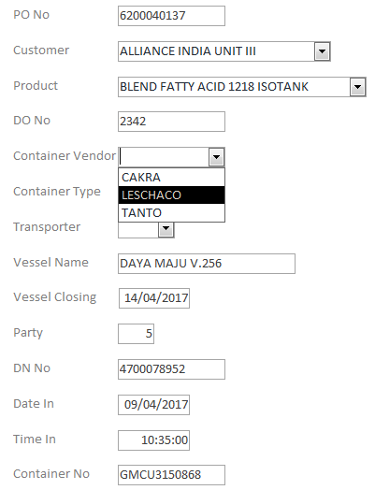

Using simple list for Container Vendor

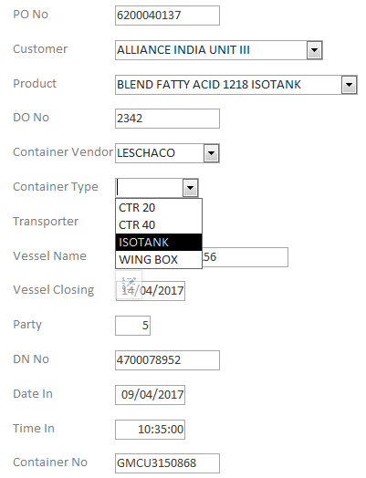

Using simple list for Container Type

(there are 5 type : CTR 20, CTR 40, ISOTANK, WING BOX, TRUCK)

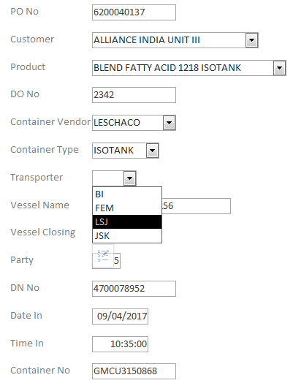

Using simple list for Transporter Name

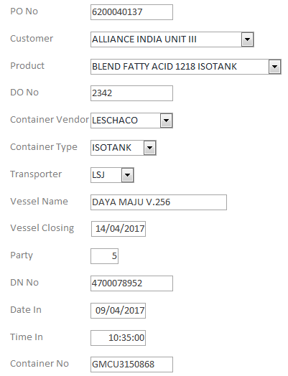

Box amount for filling DN No., automatically appear according to Number filled in Party box.

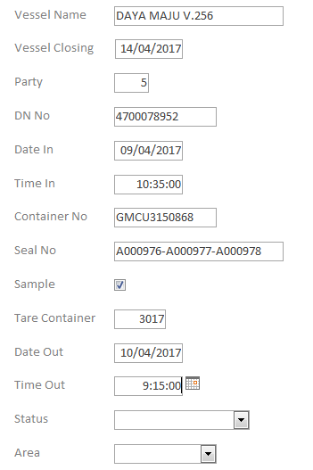

Thick if related product need sample (usually for blended product)

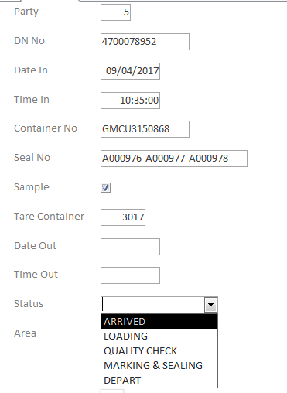

Using simple list for Status related container

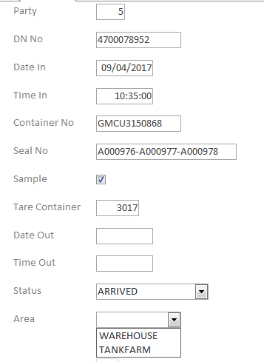

Only 2 choices of Area : WAREHOUSE or TANKFARM

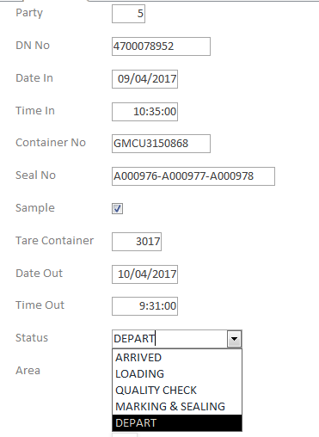

Fill only when Status of container already DEPART

1. Table of filled form. All logistics member could see this table, but “Filter” feature should be provide.



1. Warehouse & Tankfarm only have display monitor that consist of column Customer, Product, Party, DN No., Container No., and Status.

